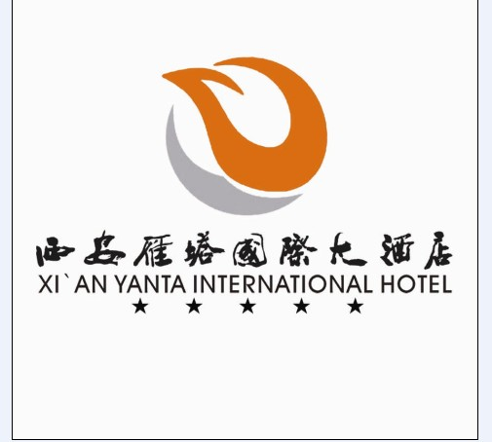
APNIC 36
20-30 August 2013

Accommodation Reservation Form

Please complete this form and send to <apnicxian@sina.cn> by 1st August 2013 to secure your booking, after this date, accommodation is subject to availability.
Guest Information
Guest No.1 Name | First Name :
 | Last Name :
Guest No.2 Name | First Name :
 | Last Name :
Nationality
Organization
Contact Details | Phone:
 | Email:
Check in Date
Check out Date
Room Type (Special offer only for APNIC 36) | ___ CNY 420 per night Deluxe Single
 | ___ CNY 420 per night Deluxe Twin
Please Indicate Room Preference | ___ Non smoking room
 | ___ Smoking room
Special Request

Credit Card Guarantee
Name on the Card
Card Type
Card Number
Expiry Date

Terms and conditions:

- Check in time is from 12:00pm and check out time is by 12:00pm. For early check in and/or late check out, rooms are subject to availability or additional fee may apply.
- The above rates quoted in inclusive of Government Tax and Service charge
- Complimentary Daily buffet breakfast
- Complimentary 24hours in room Internet access
- Credit card guarantee must accompany your reservation request, your credit card will not be charged for your advance deposit. However card will be charged for late cancellation fees and no-shows, if applicable.
- There are limited guest rooms reserved at this special rate(s) for APNIC delegates. Reservation is on first come first serve basis. In the event of Deluxe Single room is sold out, Deluxe Twin room will replace the Deluxe Single Room reservation at no extra charge.

Cancellation Policy:

- Cancel the booking by 10th August no penalty apply
- No-show reservation will be charged full length of stay

The transportation fees are listed below, please make the cash payment directly to the driver:
 | VEHICLE TYPE
 | Car with4 seats | Buick Business Purpose Vehicle with 7 seats
PRICE (RMB) | RMB 350 per order | RMB 600 per order

If you would like to reserve the airport pick up service, please fill the following form and email to apnicxian@sina.cn so that service can be arranged.
NAME
ARRIVAL DATE
FLIGHT NUMBER
ARRIVAL TIME IN XI’AN
BOOKING HOTEL
VEHICLE TYPE
SPECIAL REQUESTS

I agreed to the terms & conditions provided by above mentioned company and submit this form as the confirmation of payment.

Thank you.

(Signature as per credit card)
Name:

If you have any doubts or queries, please contact us – apnicxian@sina.cn

